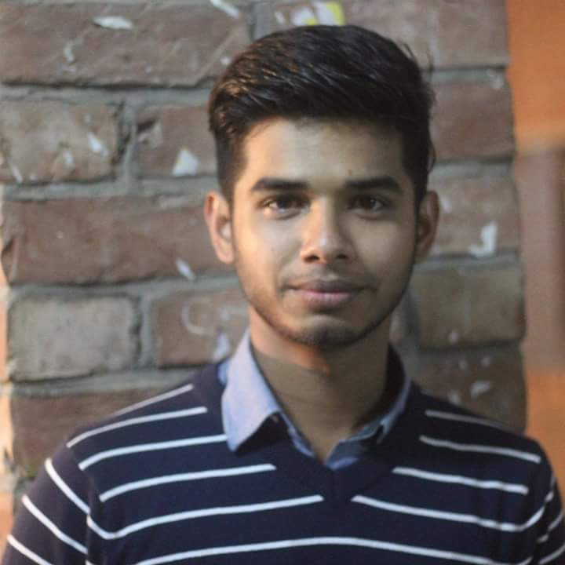

**Mohtasim Nuran**

**Computer Science & Engineering**

**(4th year 2nd semester)**

**Contact No.:** 01735448083

**E-mail:** mohtasimnuran@gmail.com

**CAREER OBJECTIVE**

To work in a firm with a professional work driven environment where I can utilize and apply my knowledge, skills and learn new technologies from new environment which would enable me as a fresh graduate to grow while fulfilling organizational goals.

B**ASIC ACADEMIC CREDENTIALS**

|  |  |  |  |
| --- | --- | --- | --- |
| **Qualification** | **Board/University** | **Year** | **GPA** |
| Computer Science & Engineering | Jahangirnagar University | 4th year 1st semester | 3.42(avg.) |
| HSC | Dhaka Board  Rajuk Uttara Model College | 2011 | 5.00 |
| SSC | Dhaka Board  Rajuk Uttara Model College | 2009 | 5.00 |

**Programming Knowledge**

* **Advance skill :** C#, Asp.Net, MVC, Html, CSS, OOP
* **Basic knowledge :**  C, C++, Java, JavaScript, python, Django framework, Angular 2
* **Database :** Microsoft SQL Server

**LEARNING C#, Asp.net & MVC framework**

* **Company Name :**  Bitm
* **Project Title :** Web Development using asp.net
* **Duration :** Three months

**PROJECT**

* University Course & Result Management System (Asp.net MVC, Entity framework, ajax, jQuery)
* Crime Investigation System (Asp.net Entity framework)
* Biding System (Asp.net MVC, Entity framework,)
* Department Automation with Class Routine & Syllabus (Django)

**INTERPERSONAL SKILL**

* + Ability to rapidly build relationship
  + Confident and Determined
  + Ability to cope up with different situations
  + Very hard working.

**PERSONAL DETAILS**

* **Father’s Name :** MOKHLASUR RAHMAN
* **Mother’s Name :** ASMA BEGUM
* **Permanents** **Address** **:** 77/1/A, Modhumita-darbarsharif road, Tongi-Gazipur
* **Date of Birth :** 28th December, 1993
* **Language Known :** Bangla, English & Hindi
* **Marital Status :** Single
* **Nationality/Religion :** Bangladeshi, Muslim
* **Interest & Hobbies :** Searching new things on internet, Football, Basketball

**REFERENCES**

|  |  |
| --- | --- |
| Dr. Md. Imdadul Islam  Professor  Department of Computer Science & Engineering  Jahangirnagar University, Savar, Dhaka  Phone: 01818729702  Email: imdad@juniv.edu | Dr. Abu Sayed Md. Mostafizur Rahman  Professor  Department of Computer Science &  Engineering  Jahangirnagar University, Savar, Dhaka  Phone: 01927129603  Email: asmmr@juniv.edu |

**DECLARATION**

I do hereby declare that the above information is true to the best of my knowledge**.**

**Mohtasim Nuran**

**(Signature)**